

台州学院
《Java高级程序设计》
实验报告

实验项目: 实验6 MVC软件架构思想应用
学号姓名: 2X计奇2X00000000无名氏
专 业：计算机科学与技术
班 级：21计应1班
实验时间：第14次课 三/四/五

电子与信息工程学院

一、实验目的及要求：
1)采用MVC架构思想，使用ThreadLocal类，自己设计并实现一个有事务管理的软件项目，理解MVC架构的优势；
2)设计并实现模拟购物系统的业务逻辑中，资金账户资金转出和商品账户转入商品数量的事务管理业务模块，理解事务管理的重要性。
二、实验内容：
1. 设计并实现模拟购物系统的业务逻辑中，资金账户资金转出和商品账户转入商品数量的事务管理业务模块。
.
三、实验代码及运行结果（包括可能有的截图）：
1.

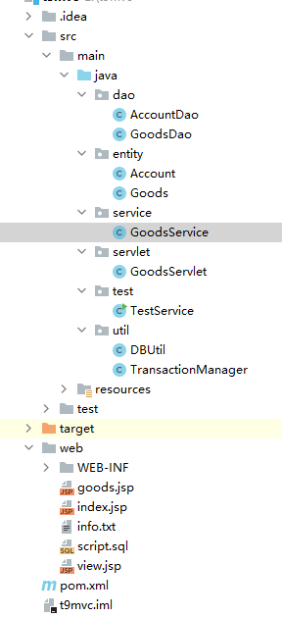

Goods.jsp
<%@ page language="java" contentType="text/html; charset=ISO-8859-1"
pageEncoding="ISO-8859-1"%>
<html>
<head>
<meta http-equiv="Content-Type" content="text/html; charset=ISO-8859-1">
<title>Insert title here</title>
</head>
<body style="font-size:30pt;">
<form action="do?path=/buy" method="post">
<fieldset>
<legend>buy goods</legend>
accountNo:<input type="text" name="accountNo"/><br/>
goodsNo:<input type="text" name="goodsNo"/><br/>
amount:<input type="text" name="amt"/>
<%String info = (String) request.getAttribute("buy_err");%>
<span style="color:red;"><%=(info == null ? "" : info)%>
</span>
<br/>
<input type="submit" value="buy"/>
</fieldset>
</form>
</body>
</html>

View.jsp
<%@ page language="java" contentType="text/html; charset=ISO-8859-1"
pageEncoding="ISO-8859-1"%>
<html>
<head>
<meta http-equiv="Content-Type" content="text/html; charset=ISO-8859-1">
<title>Insert title here</title>
</head>
<body style="font-size:30pt;">
buy success qty:<%=request.getAttribute("qty")%>
</body>
</html>

Script.sql
create database test182 default character set utf8;
use test182;
create table t_account(
id bigint primary key auto_increment,
accountNo varchar(20) unique,
balance double);
create table t_goods(
id bigint primary key auto_increment,
goodsNo varchar(20) unique,
qty double);
insert into t_account(accountNo,balance) values('001',2000);
insert into t_goods(goodsNo,qty) values('g001',0);
select * from t_account;
select * from t_goods;

dao层

AccountDao
package dao;
import java.sql.Connection;
import java.sql.PreparedStatement;
import java.sql.ResultSet;
import java.sql.SQLException;
import util.DBUtil;
import entity.Account;
public class AccountDao {
public Account find(String accountNo) throws Exception {
Account account=null;
Connection conn=DBUtil.getConnection();
PreparedStatement prep=conn.prepareStatement("select * from t_account where accountNo=?");
prep.setString(1, accountNo);
ResultSet rst=prep.executeQuery();
if (rst.next()) {
account=new Account();
account.setId(rst.getLong("id"));
account.setAccountNo(accountNo);
account.setBalance(rst.getDouble("balance"));
}
return account;
}
public void modify(Account account) throws Exception {
Connection conn=DBUtil.getConnection();
PreparedStatement prep=conn.prepareStatement("update t_account set balance=? where accountNo=?");
prep.setDouble(1, account.getBalance());
prep.setString(2, account.getAccountNo());
prep.executeUpdate();
}
}

GoodsDao
package dao;
import java.sql.Connection;
import java.sql.PreparedStatement;
import java.sql.ResultSet;
import java.sql.SQLException;
import entity.Goods;
import util.DBUtil;
public class GoodsDao {
public Goods find(String stockNo) throws Exception {
Goods goods=null;
Connection conn=DBUtil.getConnection();
PreparedStatement prep=conn.prepareStatement("select * from t_goods where goodsNo=?");
prep.setString(1, stockNo);
ResultSet rst=prep.executeQuery();
if (rst.next()) {
goods=new Goods();
goods.setId(rst.getInt("id"));
goods.setStockNo(rst.getString("goodsNo"));
goods.setQty(rst.getDouble("qty"));
}
return goods;
}
public void modify(Goods goods) throws Exception {
Connection conn=DBUtil.getConnection();
PreparedStatement prep=conn.prepareStatement("update t_goods set qty=? where goodsNo=?");
prep.setDouble(1, goods.getQty());
prep.setString(2, goods.getgoodsNo());
prep.executeUpdate();
}
}

entity层

Account
package entity;
public class Account {
private long id;
private String accountNo;
private double balance;
public String getAccountNo() {
return accountNo;
}
public void setAccountNo(String accountNo) {
this.accountNo = accountNo;
}
public double getBalance() {
return balance;
}
public void setBalance(double balance) {
this.balance = balance;
}
public long getId() {
return id;
}
public void setId(long id) {
this.id = id;
}
}

Goods
package entity;
public class Goods {
private long id;
private String goodsNo;
private double qty;
public long getId() {
return id;
}
public void setId(long id) {
this.id = id;
}
public double getQty() {
return qty;
}
public void setQty(double qty) {
this.qty = qty;
}
public String getgoodsNo() {
return goodsNo;
}
public void setStockNo(String goodsNo) {
this.goodsNo = goodsNo;
}
}

service层

GoodsService
package service;
import java.sql.Connection;
import util.DBUtil;
import util.TransactionManager;
import dao.AccountDao;
import dao.GoodsDao;
import entity.Account;
import entity.Goods;;
public class GoodsService {
public double buy(String accountNo,String goodsNo,double amt) throws Exception {
double rs=-2;
TransactionManager.beginTransaction();
try {
AccountDao accountDao=new AccountDao();
Account account=accountDao.find(accountNo);
if (account.getBalance()<amt) {
return -1;
}
account.setBalance(account.getBalance()-amt);
accountDao.modify(account);
// if(1==1)
// throw new Exception("some error");
GoodsDao goodsDao=new GoodsDao();
Goods goods=goodsDao.find(goodsNo);
goods.setQty(goods.getQty()+amt/10);
goodsDao.modify(goods);
System.out.println("amt/10:"+amt/10);
TransactionManager.commit();
return amt/10;
} catch (Exception e) {
TransactionManager.commit();
}finally{
DBUtil.close();
}
return rs;
} }

servlet层

GoodsServlet
package servlet;
import java.io.IOException;
import javax.servlet.ServletException;
import javax.servlet.http.HttpServlet;
import javax.servlet.http.HttpServletRequest;
import javax.servlet.http.HttpServletResponse;
import service.GoodsService;
public class GoodsServlet extends HttpServlet {
public void service(HttpServletRequest request, HttpServletResponse response)
throws ServletException, IOException {
String uri=request.getRequestURI();
// String path=uri.substring(uri.lastIndexOf("/"), uri.lastIndexOf("."));
String path=request.getParameter("path");
if (path.equals("/buy")) {
String accountNo=request.getParameter("accountNo");
String goodsNo=request.getParameter("goodsNo");
Double amt=Double.parseDouble(request.getParameter("amt"));
GoodsService goodsService=new GoodsService();
try {
double qty=goodsService.buy(accountNo, goodsNo, amt);
if (qty==-1) {
request.setAttribute("buy_err", "balance<amt");
request.getRequestDispatcher("goods.jsp").forward(request, response);
} else {
request.setAttribute("qty", qty);
request.getRequestDispatcher("view.jsp").forward(request, response);
}
} catch (Exception e) {
e.printStackTrace();
throw new ServletException(e);
}
}
}
}

util层

DBUtil
package util;
import java.sql.Connection;
import java.sql.DriverManager;
import java.sql.SQLException;
public class DBUtil {
private static ThreadLocal<Connection> connHolder=new ThreadLocal<Connection>();
public static Connection getConnection() {
Connection conn=connHolder.get();
if (conn==null) {
conn=getConn();
connHolder.set(conn);
}
return conn;
}
public static void close() {
Connection conn=connHolder.get();
if (conn!=null) {
close(conn);
}
}
private static Connection getConn(){
Connection conn = null;
try {
Class.forName("com.mysql.jdbc.Driver");
conn = DriverManager
.getConnection("jdbc:mysql://localhost:3306/test182?useUnicode=true&characterEncoding=utf8",
"root","root");
} catch (Exception e) {
e.printStackTrace();
}
return conn;
}
private static void close(Connection conn){
if(conn!=null){
try {
conn.close();
} catch (SQLException e) {
// TODO Auto-generated catch block
e.printStackTrace();
}
}
}
}
TransactionManager
package util;
import java.sql.Connection;
import java.sql.SQLException;
public class TransactionManager {
public static void beginTransaction() throws Exception{
Connection conn = DBUtil.getConnection();
conn.setAutoCommit(false);
}
public static void rollback() throws Exception{
Connection conn = DBUtil.getConnection();
conn.rollback();
DBUtil.close();
}
public static void commit() throws Exception{
Connection conn = DBUtil.getConnection();
conn.commit();
DBUtil.close();
}
}

运行效果

资金账户资金转出和商品账户转入商品数量页面
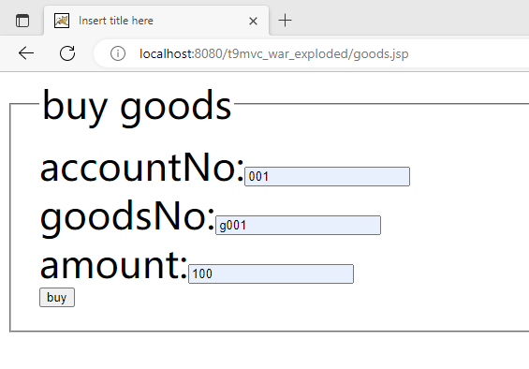
账户基本资金
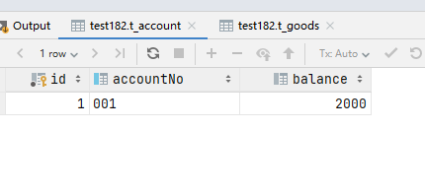
货物数量
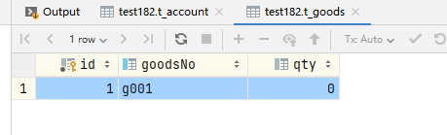

购买后
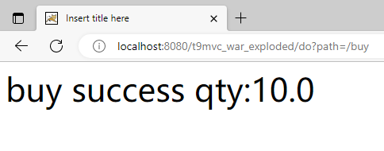
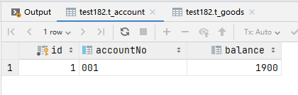
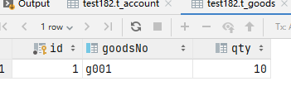

重复进行购买步骤，如果GoodsService中事物出现异常
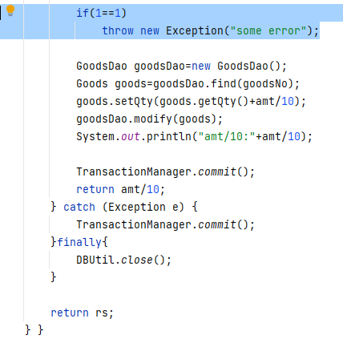

执行事务管理器TransactionManager中commit方法

看到是没有购买成功-2.0
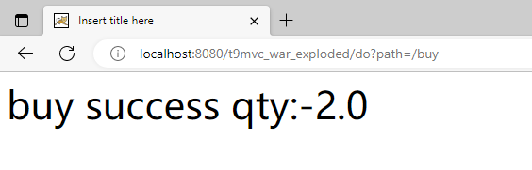
Account钱变了
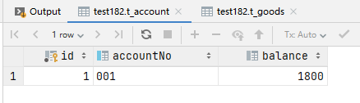

Goods中没变

执行事务管理器TransactionManager中commit方法换成rollback方法
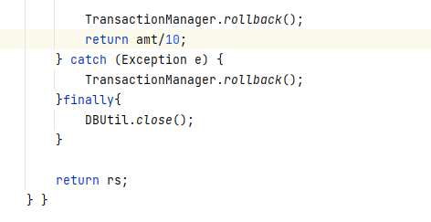

重复购买物品操作，那么账户资金和物品数量都不变

